Swanzey Operating Plan
Budget · Forecast · Capital — a consolidated operating reference

PRIVATE working document · v0.2 (auto-built from the workbooks) · June 2026
Capital tables & charts generated live from the Capital Workbook; forecast from the Financial Model
Edit the workbook input cells, re-run build, and this plan refreshes

0. Purpose
One reference holding the Town's budget, a forecast, and the capital plan together — and it is now auto-built from the workbooks: the capital tables, the funding chart, the tax-glide chart, and the forecast are generated from the Capital Workbook and Financial Model. Edit the input cells, re-run the build, and this document refreshes. Every figure traces to the Town's own reports; capital figures and forecasts are clearly-labeled planning estimates.
Operating thesis: the Town will SAVE but won't BORROW. Fund the backlog with majority-vote reserves + state aid + the water revolving fund — not bonds — and the projects that keep stalling get built without a tax spike or a 3/5 vote.

PART I — BUDGET
1. The 15-year record
Operating budgets have risen ~55% since 2012 to roughly $8.94M (2026), with a flat early-2010s (~+1%/yr) giving way to a +6–7%/yr climb since 2020.
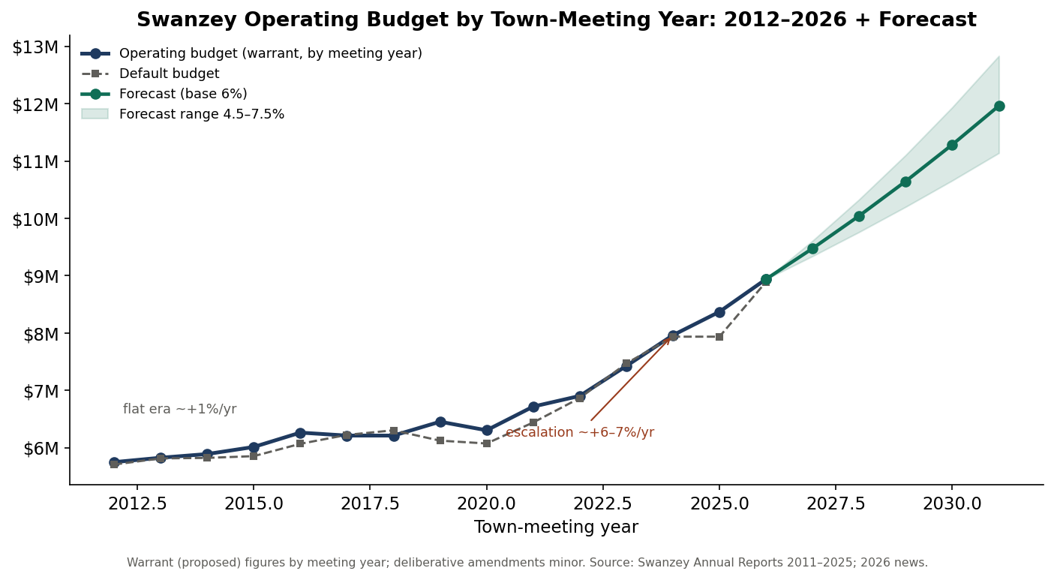
Operating budget by town-meeting year, 2012–2026, with the forecast band (Part II).
Meeting year | Operating (proposed) | Default | Budget % YES
2012 | $5,747,885 | $5,705,757 | 80%
2016 | $6,262,426 | $6,067,144 | 68%
2020 | $6,303,000 | $6,072,735 | —
2023 | $7,425,000 | $7,468,834 | 62%
2025 | $8,370,000 | $7,935,699 | 57%
2026 | $8,939,036 | $8,891,785 | passed

2. How the budget works (and why the 'no' lever is gone)
- Governing law — RSA 32. Appropriation by purpose; no over-expenditure (32:8); transfers within the total (32:10); lapse (32:7); emergency over-spend needs DRA approval (32:11).
- Forms. MS-636 / MS-737; MS-232 'Appropriations as Voted' filed within 20 days.
- SB2 default — RSA 40:13, IX. If the operating article fails, the default takes effect. In Swanzey it now sits within ~$47K of the proposal — and exceeded it in 2017, 2018, and 2023. 'Vote no to save' no longer works.
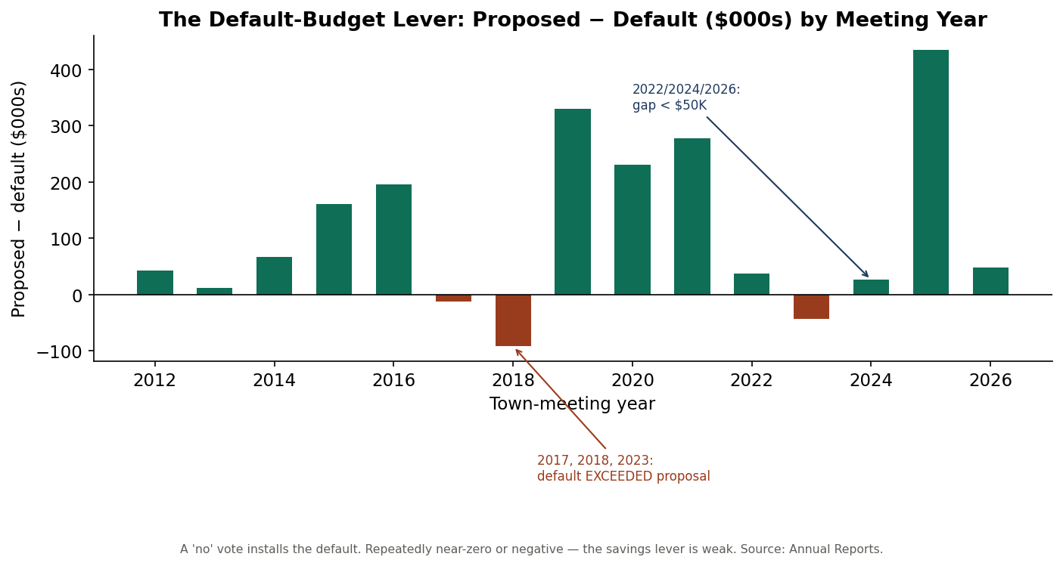
Proposed minus default budget by meeting year — repeatedly near zero or negative.
3. Cost drivers
Structural, not programmatic: health insurance, wages, the NH Retirement System (RSA 100-A) employer rate, and the ambulance/EMS contract — largely non-discretionary.
4. Tax rate & the 2024 revaluation
Total rate: $24.51 (2021) → $26.87 (2023) → $19.06 (2024) → $20.18 (2025). The 2024 drop was a revaluation, not a tax cut. Education is ~60% of the bill; the municipal share is ~a quarter.
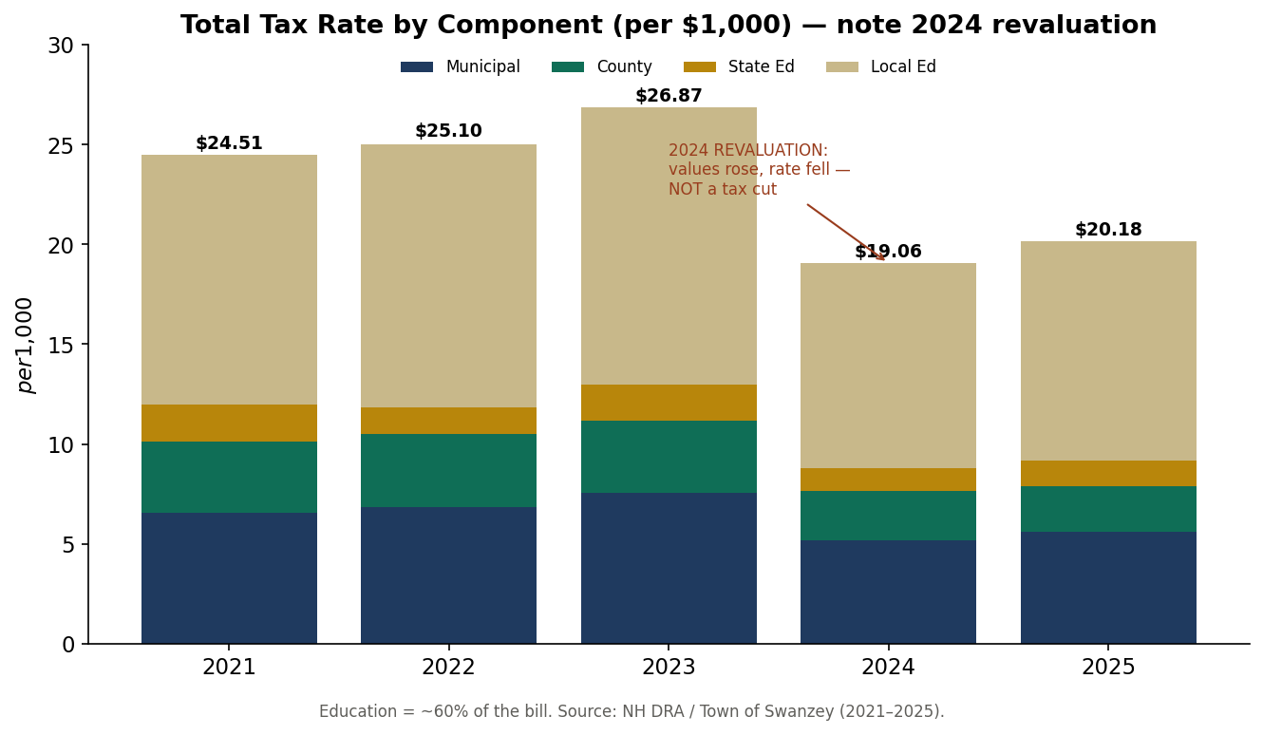
Total tax rate by component, 2021–2025.

PART II — FORECAST
Auto-built from the Financial Model (base $8,939,036; low/base/high growth). Scenarios, not predictions.
Fiscal year | Low (4.5%) | Base (6.0%) | High (7.5%)
2026 (actual) | $8.94M | $8.94M | $8.94M
2027 | $9.34M | $9.48M | $9.61M
2028 | $9.76M | $10.04M | $10.33M
2029 | $10.20M | $10.65M | $11.10M
2030 | $10.66M | $11.29M | $11.94M
2031 | $11.14M | $11.96M | $12.83M

Base case reaches $11.96M by 2031 — purely on the cost escalators.
Budget-approval risk & fund balance
Operating-budget support slid from ~80% (2011–15) to 57% (2025); a budget failure is plausible within a few cycles, though muted because the default ≈ the proposal.
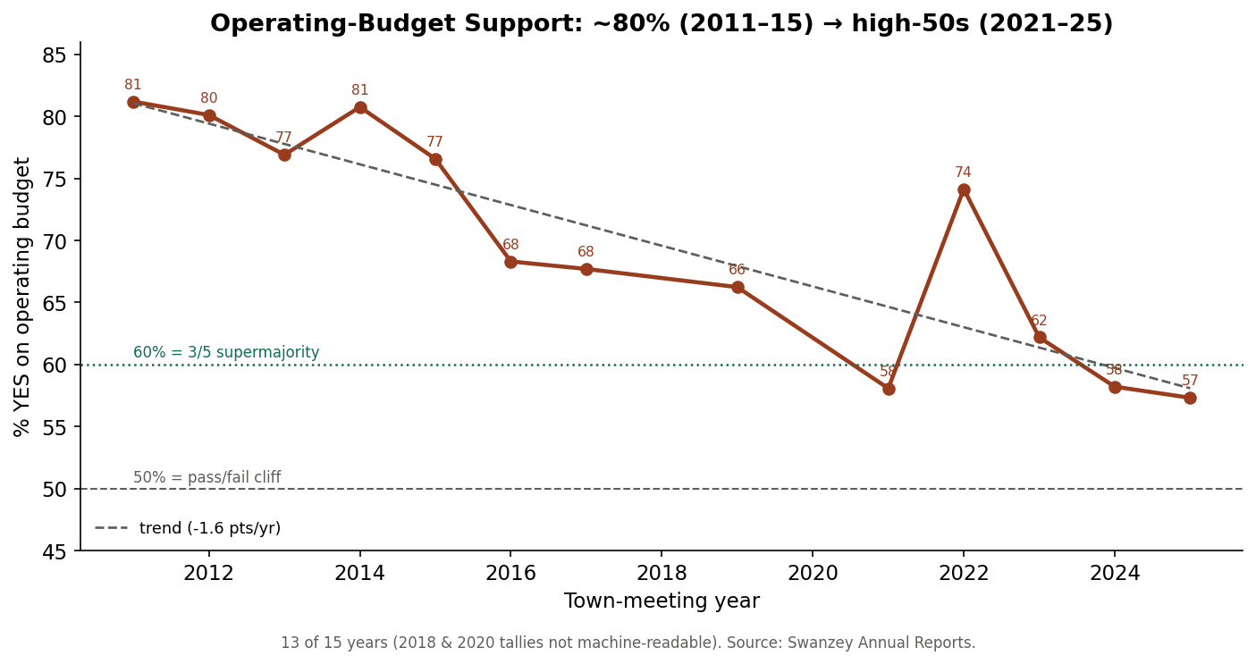
Operating-budget support, 2011–2025, with trend.
Fund-balance guidance. Hold unassigned fund balance in DRA's prudent band (≈5–17% of the operating budget); treat any amount applied to reduce taxes as multi-year smoothing.

PART III — CAPITAL PLAN
5. The backlog and the 3/5 problem
About $5.28M of identified needs. The public-works facility won majorities in 2024 and 2026 but failed the 3/5 a bond requires; reserves and credits pass 78–90%.
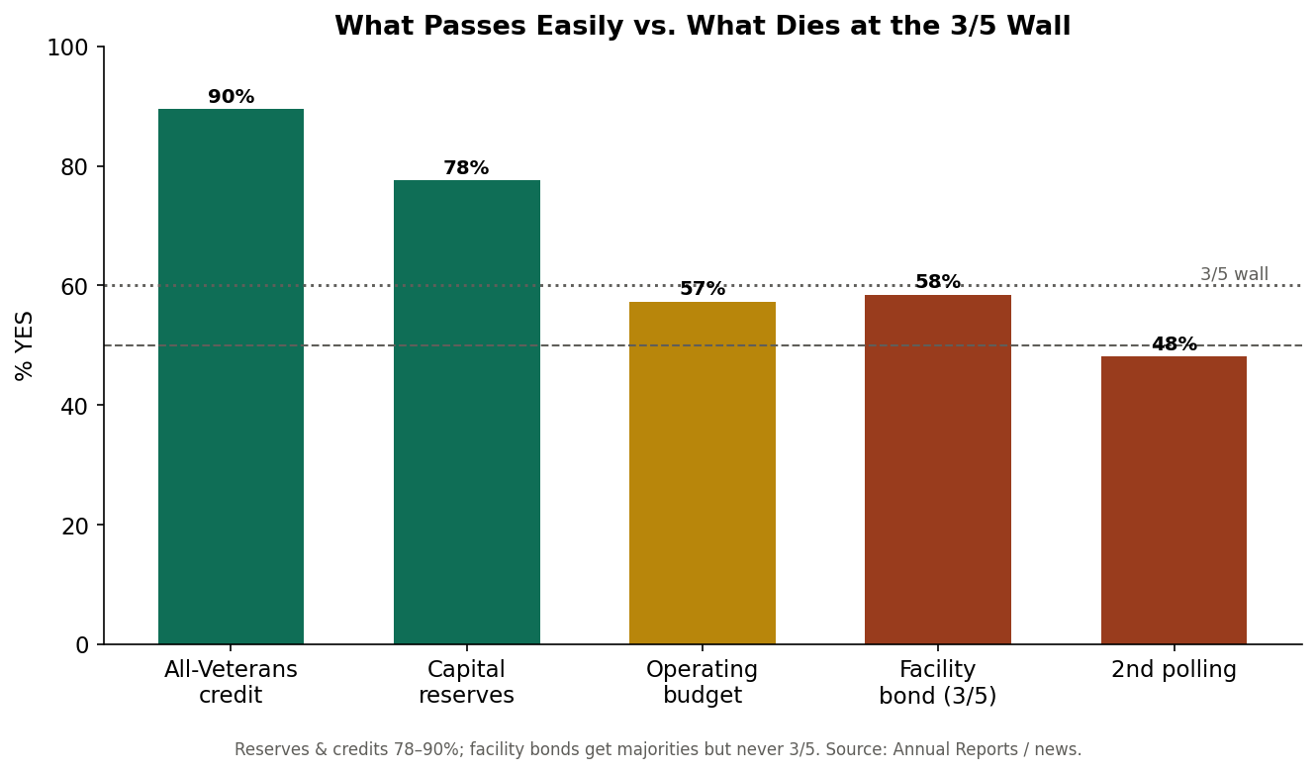
What passes easily versus what dies at the 3/5 wall.
6. The funding strategy — other people's money
About 62% of the backlog is non-property-tax money (state bridge aid, DWSRF water rates, grants), leaving $2.00M local — saved via majority-vote reserves, with $0 new bonds.
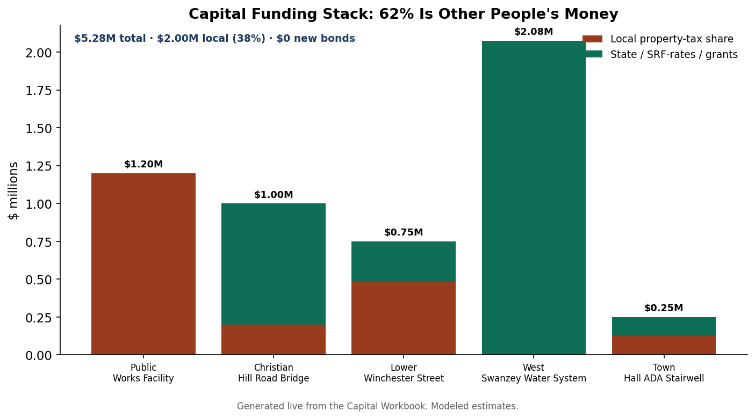
Funding stack by project (generated from the Capital Workbook).
Project | Total | Local share | Primary funding path
Public Works Facility | $1.20M | $1.20M | RSA 35 capital reserve (pay-go by ~2031)
Christian Hill Road Bridge | $1.00M | $0.20M | RSA 234 state bridge aid (80%) + bridge reserve (20%)
Lower Winchester Street | $0.75M | $0.48M | Highway block grant + roads reserve
West Swanzey Water System | $2.08M | $0.00M | NHDES DWSRF (repaid by water rates) + grants/forgiveness
Town Hall ADA Stairwell | $0.25M | $0.12M | CDBG/accessibility grant + facilities reserve
TOTAL | $5.28M | $2.00M (38%) | $0 new bonds

7. The reserve ladder & the tax glide
Capital Reserve Fund | Annual deposit | Funds | Vote
Public Works Facility | $200,000 | the facility (pay-go by ~2031) | majority
Bridges | $50,000 | Christian Hill 20% share (state pays 80%) | majority
Highway Reconstruction | $100,000 | Lower Winchester St & roads | majority
Highway Equipment | $90,000 | plow/fleet replacement cycle | majority
Fire Apparatus | $70,000 | engine/tanker cycle | majority
Town Facilities (incl. ADA) | $40,000 | Town Hall ADA, building renewal | majority
Technology & Records | $20,000 | GIS, cyber, RSA 33-A retention | majority

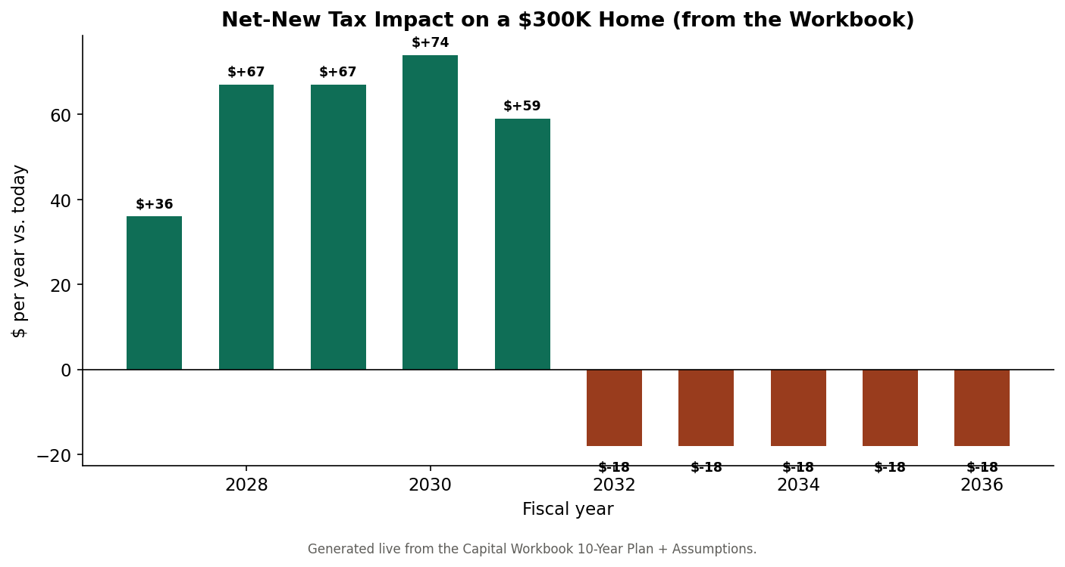
Net-new tax impact on a $300K home: peaks ≈ $74, then below today once built.
8. Decision rules
If the project is… | Use… | Because
≤ ~$250K, recurring | a capital reserve (pay-go) | simple majority, no interest
a town bridge (≥10 ft) | RSA 234 aid + reserve for 20% | state pays 80%
water/sewer | DWSRF, repaid by rates | off the property tax
large, urgent, unavoidable | Bond Bank (RSA 33) — last resort | only when reserves can't get there in time
anything | listed in the published CIP first | surprise becomes expectation

PART IV — OPERATING PLAYBOOK
9. The first twelve months
Quarter | Moves
Q1 | Stabilize the administrator's office (multi-year agreement + written evaluation). Publish a draft six-year CIP. Issue the one-page tax-bill explainer.
Q2 | Warrant & pass the capital reserve ladder (majority votes). File State Bridge Aid for Christian Hill Rd. Commission the water rate study.
Q3 | Advance DWSRF water financing. Deliver one visible small win (ADA via CDBG + reserve). Adopt operating norms for the five-member board.
Q4 | Bring the full CIP + reserve plan to the deliberative session with an information night. Report the year's progress publicly.

10. The annual municipal cycle
When | What
By Sept 1 | File MS-1 (valuation), MS-434 (revenues), MS-535 (financial report)
Oct–Dec | Build budget & default; CIP update; budget public hearing; post warrant (RSA 31:95)
~1st Tue Feb | SB2 deliberative session
~2nd Tue Mar | SB2 ballot: budget, articles, officers
Meeting +20 days | File MS-232 'Appropriations as Voted'
Fall | DRA sets the tax rate; issue tax bills

11. Dashboard — numbers to watch
Metric | Now
Capital backlog | $5.28M (62% non-tax; $2.00M local)
Peak reserve tax impact | ≈ $74/yr on a $300K home, then below today
Operating budget / support | ~$8.94M (2026); support 57% — arrest the slide with transparency
Unassigned fund balance | keep ~5–17% of operating budget
Total tax rate / valuation | $20.18 (2025); valuation input = $978.6M (REFRESH with real MS-1)
Next statutory deadline | always know it (MS-1 / MS-232 / hearing / warrant)

Appendix — Provenance & sync
Auto-built from: the Capital Workbook (Assumptions, Projects, Reserve Ladder, 10-Year Plan) and the Financial Model (Forecast). To refresh: edit the input cells in those workbooks, then run build_from_workbook.py + render_opplan.py. Real figures from the Town's annual reports (2011–2025), NH DRA, and local news; capital figures and forecasts are planning estimates. Key statutes: RSA 32, 40:13, 35, 33/35-A, 234, 38, 162-K, 674:5-8, 91-A, 33-A, 165, 273-A, 100-A.

